# Fiori Architecture

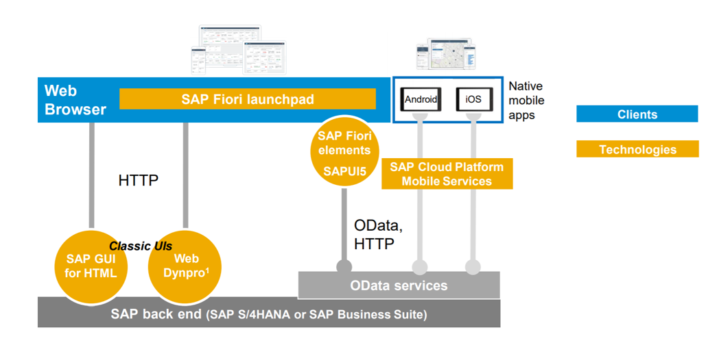

## Embedded Approach

SAP Backend (Business Data) ERP- UI Addon CRM- UI

Web browser

## Central hub Approach- (SAP Recommended Approach)

We need to have separate FES for managing Fiori Apps.

Web Browser

SAP S4 HANA/ Backend server

Fiori Front End Server(FES) – NetWeaver Gateway

Transactions/ Factsheet/ Analytical Apps